**Web Traffic Time Series Forecasting Using FB Prophet Model**

**Abstract:**

This project report explores the application of the FB Prophet model in forecasting web traffic time series, a critical task in the digital realm where online presence translates directly into business success. By leveraging historical web traffic data, this study seeks to demonstrate the utility of FB Prophet in generating accurate predictions, thereby empowering organizations to make informed decisions regarding infrastructure scaling, marketing initiatives, and user engagement strategies.

**Introduction:**

In an increasingly interconnected world, the ability to anticipate and adapt to fluctuations in web traffic is paramount for businesses seeking to maintain a competitive edge. Traditional time series forecasting methods often struggle to capture the nuances of web traffic patterns, which are influenced by factors such as seasonality, trends, and external events. The FB Prophet model, developed by Facebook's Core Data Science team, offers a promising alternative, boasting the ability to handle such complexities with ease while providing interpretable and reliable forecasts.

**Web Traffic Time Series Dataset:**

The dataset utilized in this study represents a treasure trove of historical web traffic data, encompassing a diverse array of platforms, from e-commerce websites to social media networks. With granular timestamps and corresponding traffic metrics, this dataset offers a comprehensive snapshot of user behavior over time, enabling thorough analysis and modeling.

**What is Time Series Analysis?**

Time series analysis is a statistical approach that entails gathering data at consistent intervals to recognize patterns and trends. This methodology is employed for making well-informed decisions and precise forecasts by leveraging insights derived from historical data.

And the process of predicting the future values of the data by analyzing the previous trends and patterns hidden in the data is known as time series forecasting. Time series forecasting can be done using various forecasting techniques like ARIMA, SARIMA, Prophet, Theta and other statistical method. Time series data is a sequential data hence, deep learning-based methods like RNN, LSTM, BLSTM and GRU are also used for time series forecasting.

**Why use FB Prophet over other models?**

1. Ease of Use: FB Prophet is designed to be user-friendly, with intuitive parameter tuning and minimal requirements for data preprocessing. This makes it particularly suitable for users without a deep background in time series analysis.

2. Handling of Seasonality: FB Prophet is adept at handling multiple seasonality patterns, such as daily, weekly, and yearly seasonality, without the need for explicit feature engineering. In contrast, capturing seasonality in ARIMA models often requires manual intervention and domain knowledge.

3. Flexibility: FB Prophet can accommodate irregularly spaced time series data and missing values more gracefully compared to ARIMA, which typically assumes evenly spaced observations.

4. Interpretability: FB Prophet provides transparent diagnostics and interpretable components, allowing users to understand how different factors contribute to the forecasted values. This transparency can be valuable for decision-making and model validation.

5. Automatic Trend Detection: FB Prophet automatically detects and models non-linear trends, making it well-suited for datasets with complex temporal patterns. ARIMA, while capable of capturing trend information, may require manual specification of differencing orders and trend components.

**Facebook Prophet Library**

Prophet is an open-source tool from Facebook used for forecasting time series data which helps businesses understand and possibly predict the market. It is based on a decomposable additive model where non-linear trends fit with seasonality, it also takes into account the effects of holidays. Before we head right into coding, let’s learn certain terms that are required to understand this.

Trend: The trend shows the tendency of the data to increase or decrease over a long period of time and it filters out the seasonal variations.

Seasonality: Seasonality is the variations that occur over a short period of time and is not prominent enough to be called a “trend”.

**Problem Statement:**

Investors are considering making an investment in a new e-commerce website ABC. But they would only make the investment if they can get a healthy number of monthly users(upward trending) with in next 10 months.

You need to help Unicorn ventures with the decision. They usually invest in B2C start-ups less than 4 years old looking for pre-series A funding. In order to help Unicorn Ventures in their decision, you need to forecast the traffic on ABC for the next 7 months.

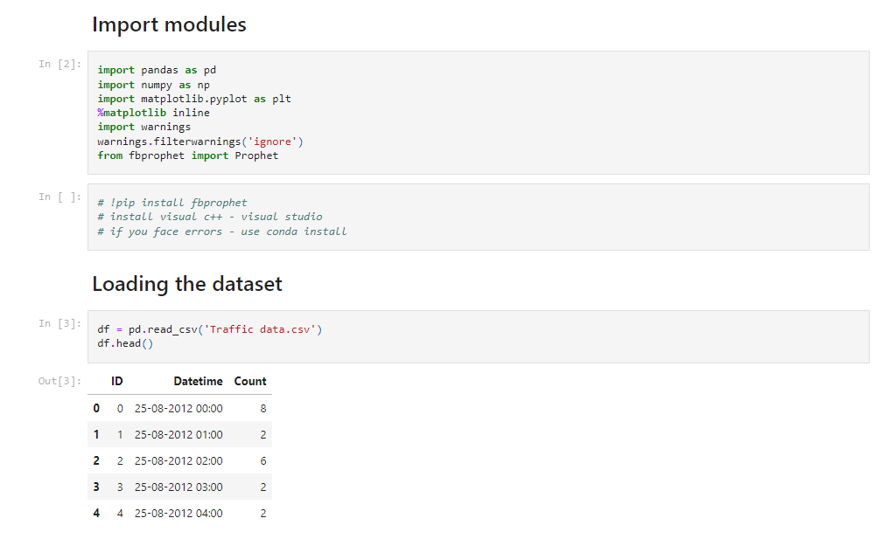

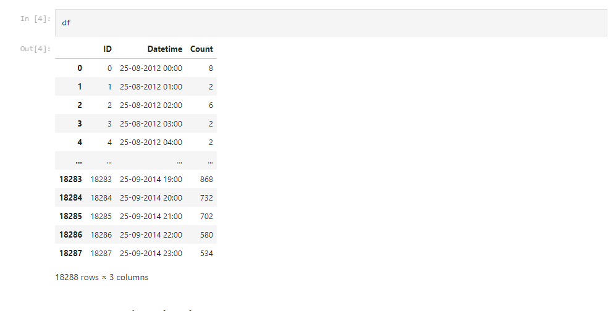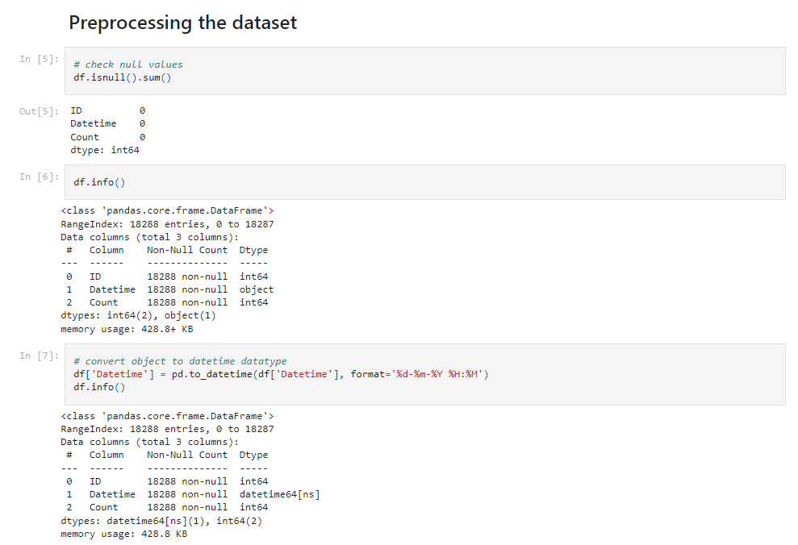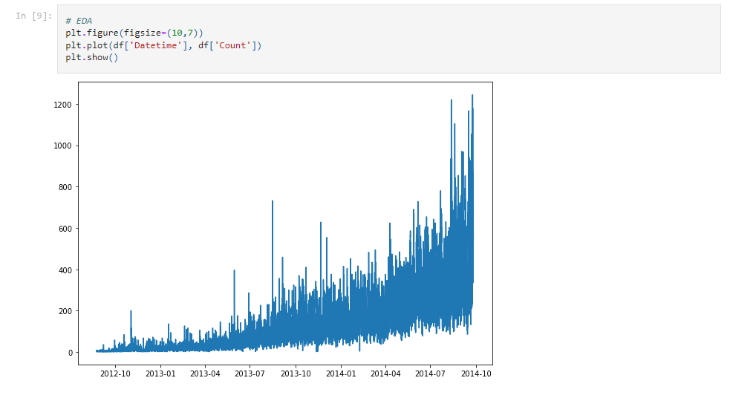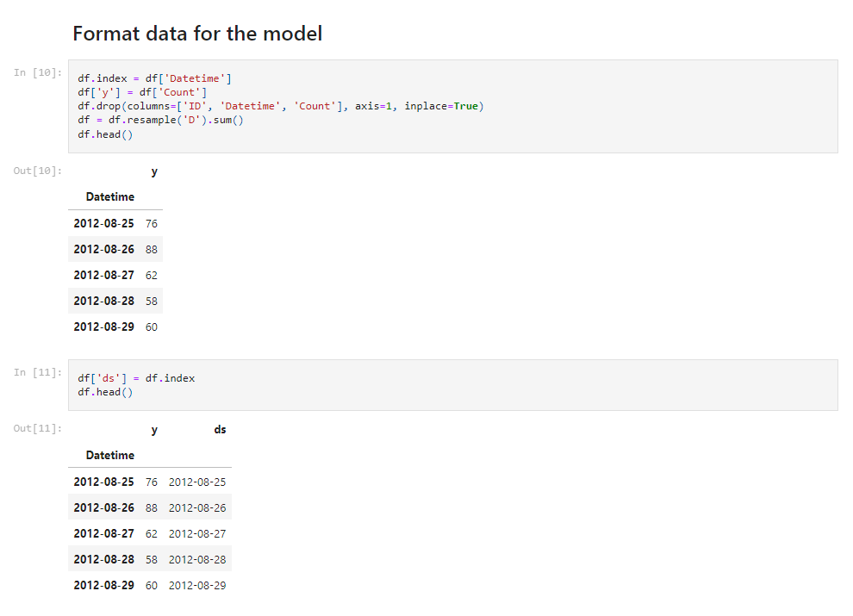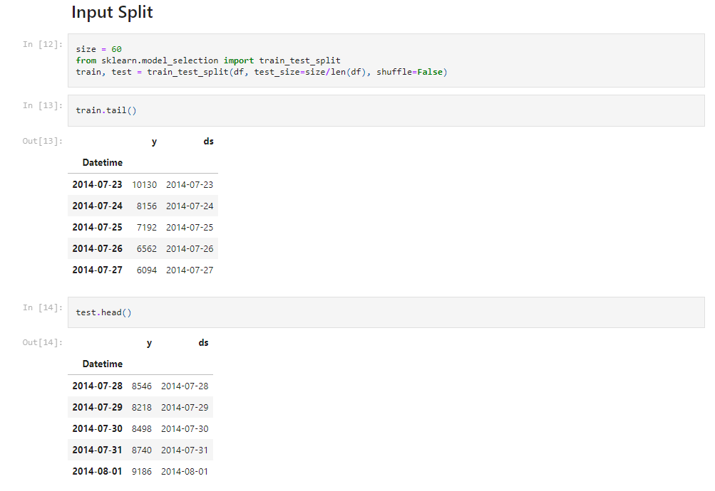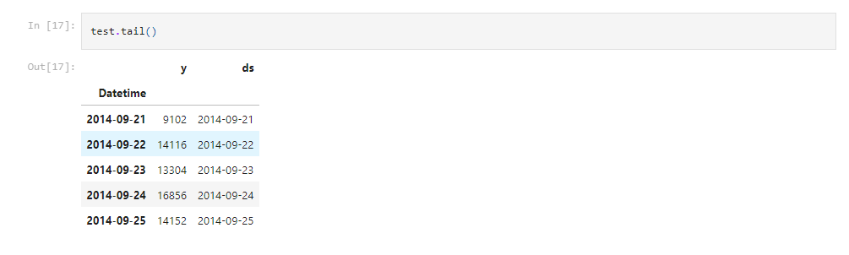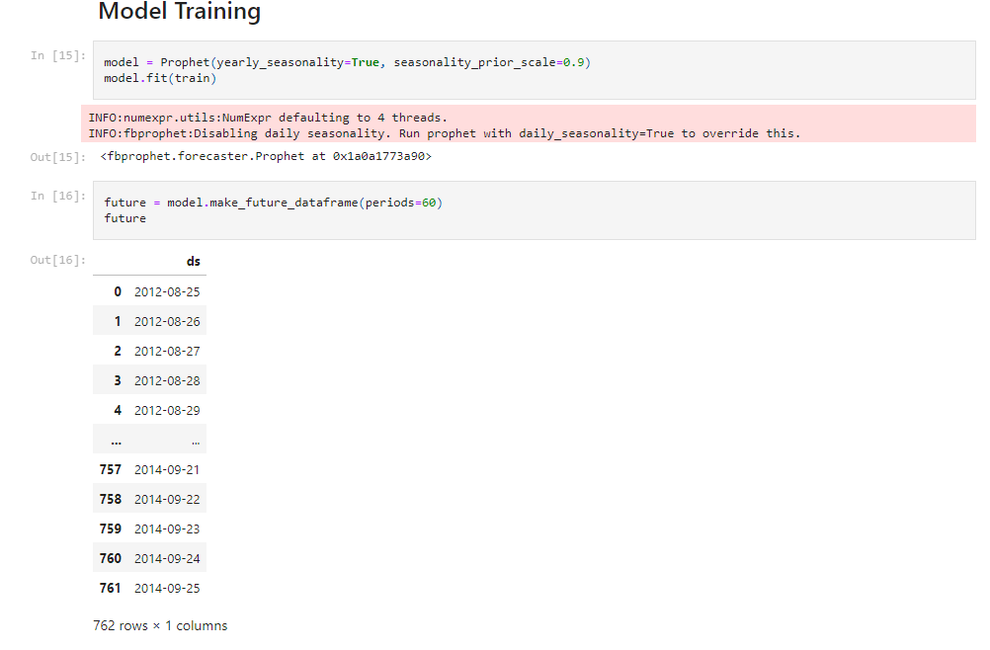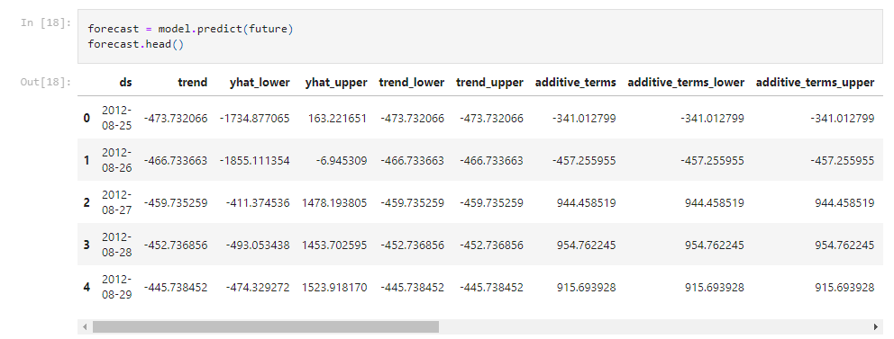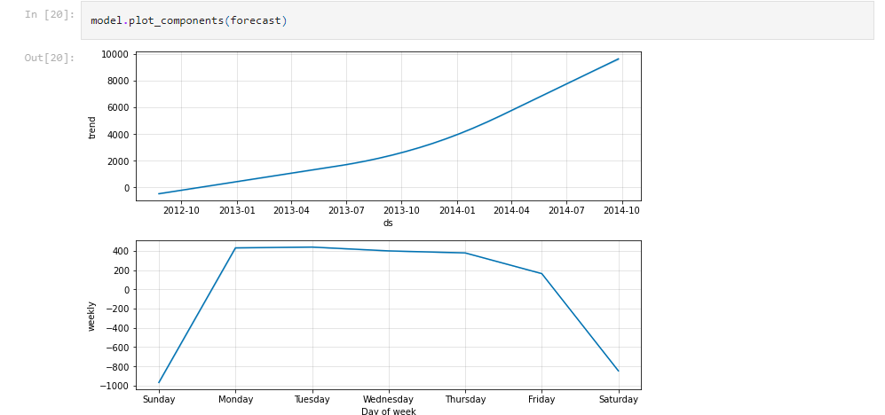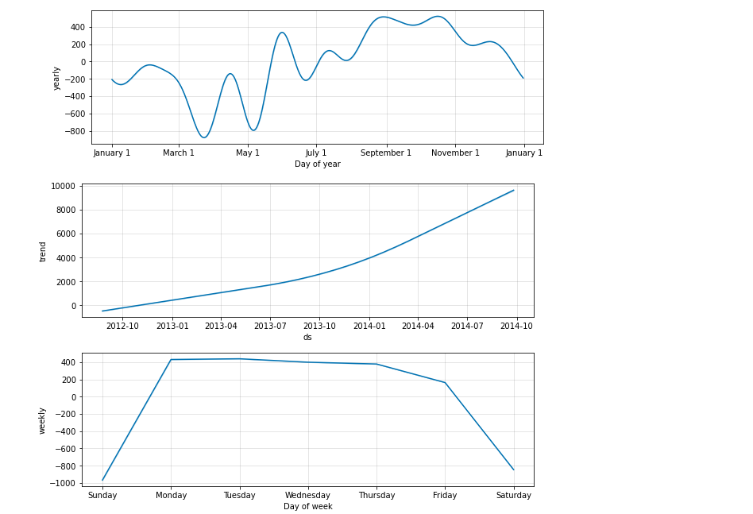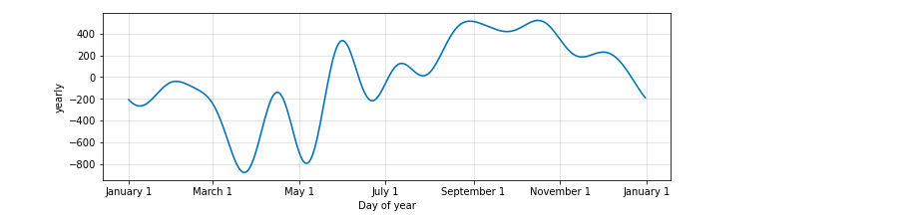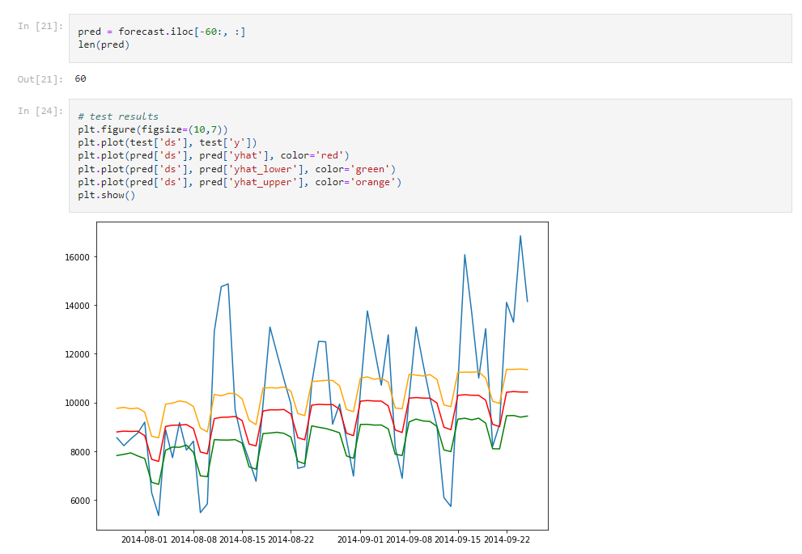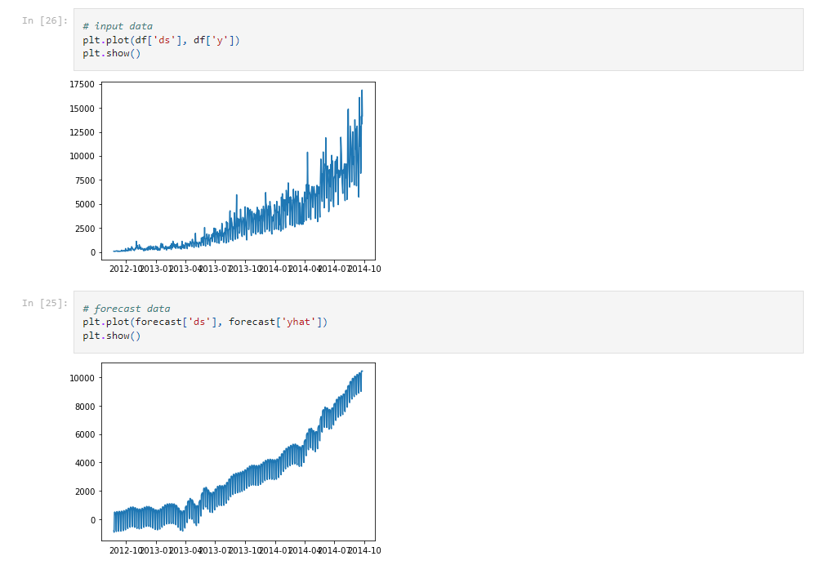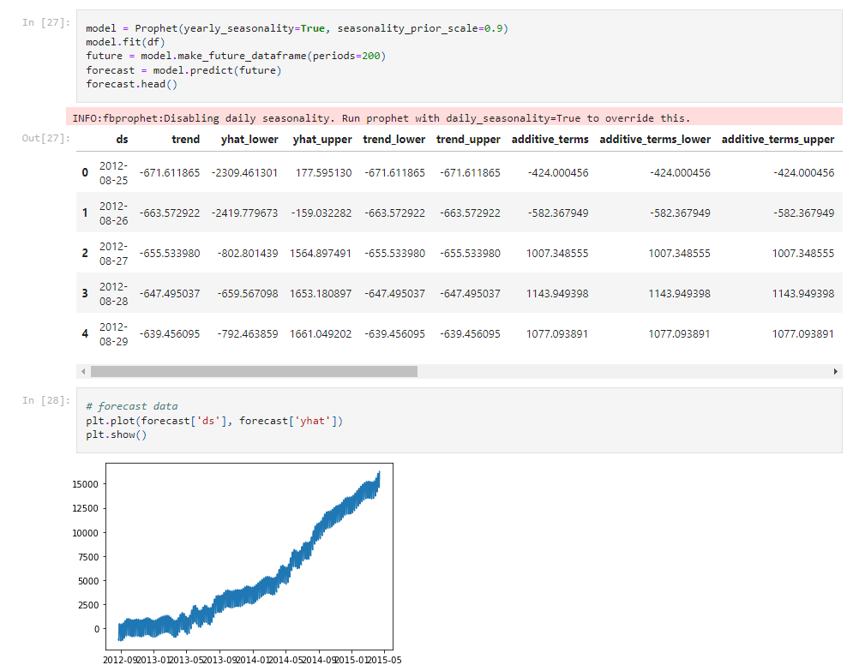

**Conclusion:**

From above prediction 200 days we can clearly see the trend is rising and a good number of users are engaging so we can say to the investor that ABC’s future performance will be very good so they can invest on them.

**Future Work:**

Time Series Forecasting is one of the least explored areas and various models are evaluated to improve the accuracy of the forecast. The main focus of the proposal is to predict future web traffic to make better decisions. Past Values are considered to predict future values. We will also try to tweak the hyper parameter to get more accurate results which will lead us to more accurate predictions.

**References:**

[1]"Predicting Computer Network Traffic: A Time Series Forecasting Approach using DWT, ARIMA and RNN" by Rishabh Madan,2018.

[2] “Fast ES-RNN: A GPU Implementation of the ES RNN algorithm” by Andrew Redd and Kaung Khin,2019.

[3] “Time Series Forecasting Based on Complex Network Analysis “by SHENGZHONG MAO AND FUYUAN XIAO,2019.

[4] “Web Traffic Prediction of Wikipedia Pages” by Navyasree Petluri, Eyhab Al-Masri,2019.

[5] “Time series forecasting using improved ARIMA” bySoheilaMehrmolaei,2016.